Project Proposal: Multiuser Poker Game for Mobile Devices

4276228 Matthew Winterbourn (psymw6)

25th September 2018

**Background and Motivation**

Mobile gaming has fast become one of the most profitable markets for gaming in the world, with projected revenue for 2018 marking the first time that more than half of all game revenues will come from the mobile segment and with revenue from mobile games alone projected to become a 100 billion dollar market by 2021 [1], from this we can see the stunning growth in popularity of mobile games and especially the rise of multiplayer games which accompanied the advent of third generation network (3G) technologies [2].

Following this it seems essential that in this new age where anyone can open their phone and expect to load up a multiplayer game and have it work almost anywhere that the game servers supporting this should be able to provide a robust and stable experience in order to retain a player base in today's competitive market with Sensor Tower projecting the Apple app store alone to reach 5 million apps by 2020 [3].

Furthermore, the ownership of mobile phones and, more specifically, smartphones has increased dramatically over the years, from 35% in 2011 to 77% of US adults in 2018 [4]. With this increase in ownership it should be fair to assume that there is a significant portion of smartphone owners across the world that have varying degrees of disabilities i.e visual or physical impairments that restrict their ability and studies done by the Rehabilitation Engineering Research Center for Wireless Technologies have shown that 84% of people with disabilities own or use a cell phone or smartphone and including tablet raises the rate to 91% [5].

It might then appear that since there is such a large percentage of people with disabilities using this technology that there would be plenty of support to aid them where they might struggle more than your average person, and this does indeed seem to be the case when you look at standard features such as text to speech and gesture control helping out those lacking in fine motor control, or the visual aid options for those with visual impairments. A quick search for such support in mobile gaming, however, does not reveal quite such promising results. Games such as TapBeats [6] do exist however their prevalence on the android platform appears incredibly sparse, with one aggregate site listing roughly 100-200 accessible apps [7] which are a tiny fraction of the millions of apps available for download on the google play store.

This conclusion led me to believe there to be quite a large gap in the android OS for games that were easy to pick up and play for people of all abilities and it seems reasonable to use this multiplayer poker game to explore different methods of navigating interfaces and gameplay that would allow for an inclusive experience for anyone who wishes to play.

The primary language for this project should be java as it is the primary language for android mobile devices and as such has the largest library of available resources which will prove helpful in implementing planned accessibility features which might prove to be more tricky in other languages.

Android Studio provides a robust framework for application development, being the official IDE for android and also has support for JUnit testing, making the process of test driven development much smoother to implement.

This proposal had considered using Corona which advertises as specifically built for creating 2D mobile apps, mostly games, using LUA scripting with the ability to call native libraries or apis in languages such as java/C. However upon further research the support for implementing native google accessibility features was not feasible. This was due to potential compatibility issues and although there were a few plugins that appeared to have their own implementation of similar features, they were only available at a premium and ultimately the complications did not appear to be worth the benefits offered by using Corona.

Evaluating this project should come from small test groups involving cognitive walkthroughs as well as cooperative evaluations to ensure that the UI and UX is as usable and accessible as possible. More specifically designing specific tasks for users to go through in order to explore the app and receive feedback in real time on their first impressions, ideally conducting these throughout development and iteration of the UI in order to prevent having to redesign anything once the app has been fully implemented, hopefully resulting in a strong, well defined UX with an easy to understand and good looking UI in the final deployment.

This project’s biggest challenge to be implementing accessibility features such as speech recognition and voice announcements for the state of the game, in order to aid people who may struggle with using controls or be visually impaired for example. Another challenge would be to handle communication in real time between devices keeping them all updated efficiently and without dropping connection when one user leaves the game. In order to achieve these goals we will consider different approaches to accessibility and multiplayer connection to find the best way to implement the desired features.

**Aim and Objectives**

The aim of this project is to build a multiplayer texas holdem poker app for android devices which is capable of hosting a game and removing players with a dropped connection without affecting the gameplay of the other players whilst providing an accessible experience to various types of users at different levels of ability and proficiency in handling a mobile device.

The objectives of this project are:

* Create an enjoyable and robust game of poker capable of running across a multitude of android devices.
* Be able to play in a multiplayer capacity communicating in real time with other users over a stable connection with handling for users that lose connection.
* Ensure random shuffling of cards to prevent users being able to gain any sort of unfair advantage.
* Implement an easy to understand and intuitive control scheme.
* Create an interface that can be understood at a glance by most users.
* Discover and implement various features for increased accessibility to users with different levels of ability to interact with the phone such as impaired vision/hearing.

**Work Plan**

This app should follow the principles of test driven development in order to create a stable and usable app that fits the requirements correctly. Following this test driven nature there should also be formative evaluations by test users to receive feedback on the design and functionality of the system throughout the stages of testing and this lends itself to a more agile methodology, which allows for changes in design and scope of the project that could arise from the test users. Testing is for the most part omitted from the plan since it should be integrated at all stages of development.

We will consider different algorithms for card shuffling and hand calculation to determine the most suitable for use in the app. This is in order to safeguard against cheating and provide a better overall experience for the user.

Testing should be rigorously planned in order to cover all functioning aspects of the front end interface to ensure usability e.g making sure all buttons work as intended and the rules of the game are upheld by the system. This app should also have rigorous testing for the backend server to ensure connection and error handling is handled appropriately with the correct responses. Tests should be designed and coded before implementing the next planned feature.

Evaluation of this app should be executed in 2 stages. Firstly, evaluation of a low resolution prototype as a formative evaluation involving the use of cognitive walkthrough and cooperative evaluation. This should be recorded with a written summary of results from the cognitive walkthrough, and the completion of a survey pertaining to the cooperative evaluation. Finally, the app should be evaluated at its completed state to understand the learnability of the app as well as the efficacy of the network and usability features. This should be completed with a survey consisting of several closed questions on the overall function of the app as well as some open ended questions allowing the test users to express their thoughts on the app.

1. Write a completed rough formal project proposal
2. Research extensively into the most appropriate tool(s) for development and testing
3. Finish formal project proposal with feedback from supervisor
4. Research into the system features for development of accessible apps and the feasibility of implementing such systems, as well as potentials algorithms for card shuffling
5. Create a list of requirements
6. Create an initial list of tests
7. Prototype UX/UI designs
8. Receive feedback on designs and iterate on it until a satisfactory design is reached
9. Produce interim report
10. Produce UI frame for game
11. Take time off for christmas holidays
12. Develop functionality of poker game on client side front end
13. Integrate functionality with UI
14. Develop backend for communication between nodes (phones)
15. Complete testing of apps usability between users of varying ability
16. Write final dissertation detailing the successes of the project and the problems encountered and overcome

**Timeline:**

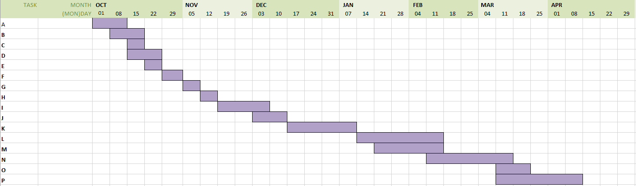

**References**

[1] <https://newzoo.com/insights/articles/global-games-market-reaches-137-9-billion-in-2018-mobile-games-take-half/>

[2] <https://www.researchgate.net/publication/49288100_Exploring_the_Impact_of_Use_Context_on_Mobile_Hedonic_Services_Adoption_An_Empirical_Study_on_Mobile_Gaming_in_China>

[3] <https://sensortower.com/blog/app-store-growth-forecast-2020>

[4] <http://www.pewinternet.org/fact-sheet/mobile/>

[5] <http://scholarworks.csun.edu/bitstream/handle/10211.3/190202/JTPD-2017-p50-66.pdf?sequence=1>

[6] <http://www.joyk.im/projects/tapbeats/tapbeats_paper.pdf>

[7] <https://www.androidaccess.net/>